**Deployment Package Preparation**

**Author**  : Mogomotsi Modise

**Date Created**  : 21 June 2013

**Document Owner**  : Sasfin Bank

**Executive summary**

This document provides a step by step process of deploying the DOD application to any environment (i.e. UAT, Production).

**Process:**

1. Unzip Jboss in the following path E:\Apps

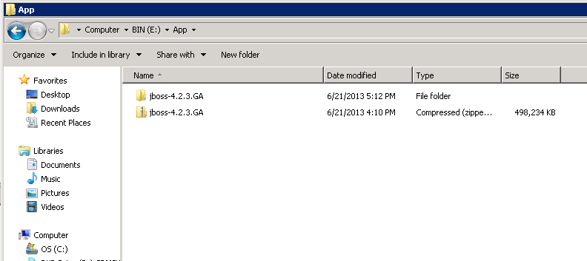

1. Make a copy of the “default” server config folder in the same directory.
2. Rename one copy to “fxonline”.

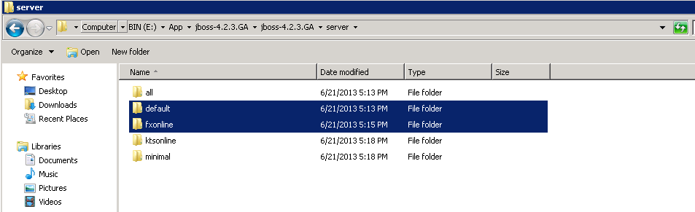

1. Setup and configure databases and user roles

4.1 Open pgAdmin Tool

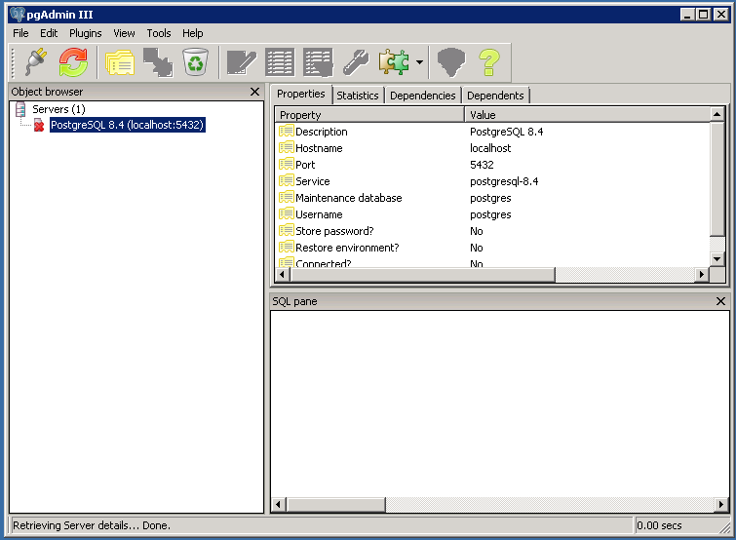

4.2 Connect as a super user

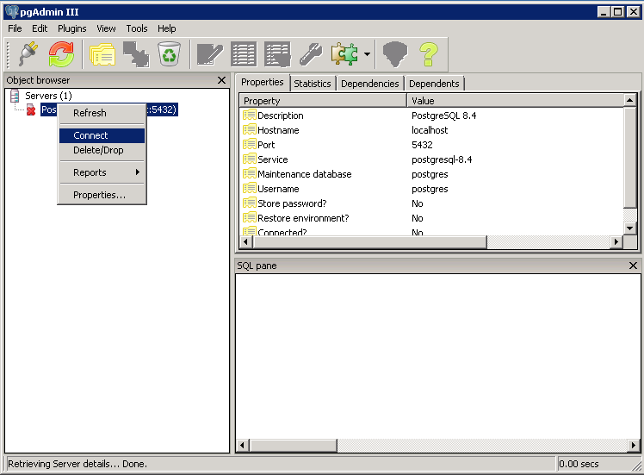

4.3 Create create the following user Roles:

* Holidayadmin
* Propertyadmin
* Ratesadmin
* Fxonlineadmin

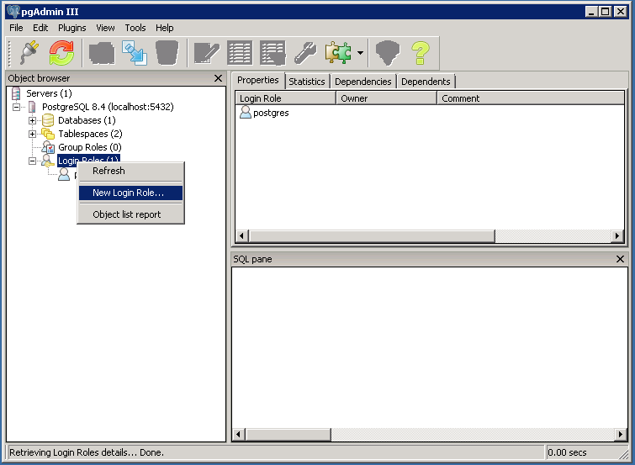

4.4 Create the following Databases using the right User Roles:

|  |  |
| --- | --- |
| DataBase | Owner |
| Rates | ratesadmin |
| currencyholiday | Holidayadmin |
| Ktsproperties | Propertyadmin |
| fxordering | fxonline |
|  |  |
|  |  |

4.5 for each User created, Connect that user and restore its corresponding databases with the corresponding backup database.

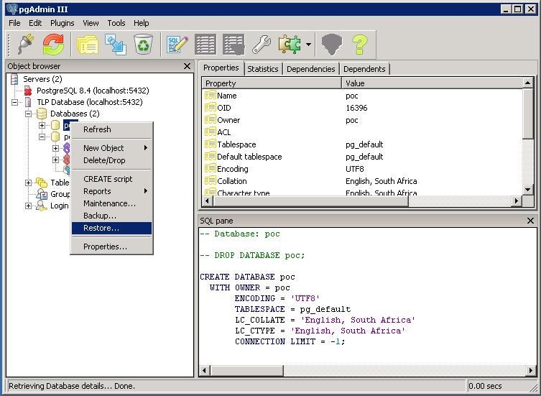

5. Open the source code in eclipse

6. On the Ant Tab, select and expand the “OnlineForexOrdering” and double click on the “buildOnlineForexOrderingJar_JBoss[default]” .

7. Wait for a successful build

8. repeat step 6 and 7 for “OnlineForexOrdering_WEB” and the “build [default]” file

9. Under the Navigator Tab, Expand the archive folder in the” OnlineForexOrdering_WEB” solution and copy the .war file to the following Directory:

E:\App\jboss-4.2.3.GA\jboss-4.2.3.GA\server\fxonline\deploy\fxonline

10. Run the “runfxonline” batch file

11. On your browser go to the following link “http://locahost:8080/forexordering”